Hilton
GRAND VACATIONS

Hiring Event

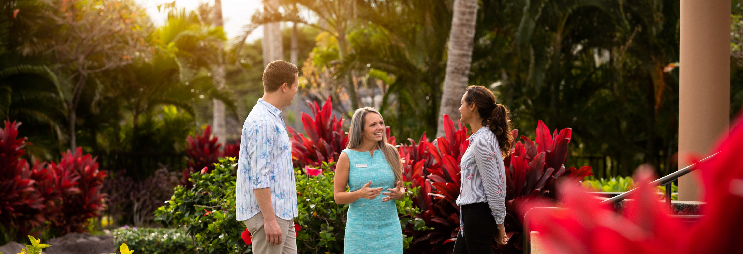
Set Your Career Course for Success
Join us for a special hiring event where you can explore your opportunities, interview on-site, and get a conditional job offer on the spot. Our Team Members enjoy an energetic, inclusive environment while helping make amazing vacations possible, and
we're welcoming new talent every day. Come see what Hilton Grand Vacations offers and find your career with us.
Apply online at hgv.com/careers
or scan the QR code to get started.
Hiring Event
Wednesday, May 24, 2023
Time
12:00 PM – 6:00 PM
Location
475 E. Bay Street, Charleston, SC 29403
Complimentary Parking
Positions Available
- Bartender (full & part-time)
- Food & Beverage Manager
- Club Lounge Attendant (full & part-time)
- Housekeeper
- Housekeeping Supervisor
- Houseperson
- Senior Housekeeper
- Common Area Attendant
- Maintenance Tech II
- Security Associate

DAY 1 BENEFITS | Daily Pay | Opportunity for Quarterly Bonus
Please dress for success and bring printed copies of your resume.
Walk-ins are welcome. Feel free to bring a friend!
0
For more information, please call 843-410-8821.
Search HGV Careers to find us on social,

Hilton Grand Vacations is a registered trademark of Hilton Worldwide Holdings Inc. or its subsidiaries and licensed to Hilton Grand Vacations Inc. Hilton Grand Vacations and its properties and programs operate under the Hilton Grand Vacations name pursuant to a license agreement with Hilton Worldwide Holdings Inc.
rs 2022 Hilton Grand Vacations Inc.

TA-FLYER-589294 EOE/Disabled/Veterans

